Labour market matching across skills and regions in Australia
Will Mackey
Summary
This paper explores patterns of searching and matching in the Australian labour market. It first estimates matching efficiency between 2004 and 2023 at the national level, showing 3 distinct periods: a more efficient labour market leading up to the Global Financial Crisis; a decade-long slump from 2010 with low matching efficiency and growing rates of long-term unemployed; and a period of instability from 2020 when an unprecedentedly tight labour market was met with strong job finding rates causing aggregate matching efficiency to rise throughout 2022. Unemployed people were more likely to find work in 2022 than at any point since data began in 2004. This was true for short, long and very long-term unemployed people.
One source of mismatch – skill mismatch – is examined to show that higher skilled workers tend to experience tighter labour markets and lower levels of within-skill mismatch compared to lower-skilled groups. Between-skill employment mismatch means that higher skilled workers can crowd out lower-skilled workers and job seekers.
The national labour market is then divided along regional and skill level lines to show heterogenous conditions in 111 local labour markets. By controlling for some sources of geographic and skill mismatch, this analysis demonstrates that mismatch remains within region-skill labour market cells.

- Introduction
The Beveridge Curve is the relationship between job vacancies and job seekers in a labour market. A tighter labour market indicates that there are more vacancies for each unemployed person, and a looser labour market means there are more unemployed people for each vacancy. Chart 1.1 shows Australia’s Beveridge Curve from the late 1970s to May 2023. There was high unemployment and low vacancies in the late 1980s and early 1990s. The labour market tightened into the 2000s except for a period of loosening at the onset of the Global Financial Crisis. The 2010s were relatively stable with the vacancy rate of 1–2 per cent and unemployment rate between 4.5–6.5 per cent. With the COVID-19 pandemic shock from 2020, unemployment grew temporarily before vacancies rose to the highest level on record.
While these shifts reflect cyclical features of the labour market over time, how well job seekers and jobs are ‘matched’ has an important role. Matching efficiency reflects the labour market’s ability to match individuals to jobs, which can be limited by disconnects between the skills and location of potential workers, and the requirements, renumeration, and location of available jobs. A more efficient labour market will have lower levels of unemployment for the same level of labour demand. Improving matching efficiency drives down the natural rate of unemployment and reduces skills shortages in the economy.
Improving matching efficiency in the labour market means Australia can generate more economic output for a given level of available workers and demand for labour. This paper first uses detailed vacancy, job seeker and matching data to explore changes in labour market matching efficiency in Australia between 2004 and 2023 for a range of job seeker groups. The paper then explores skill level variation in labour market tightness and looks at occupation transitions within and between skill groups. The final section adds a regional lens to illustrate the heterogeneity of local labour markets that can coexist across Australia.
        - The Beveridge Curve
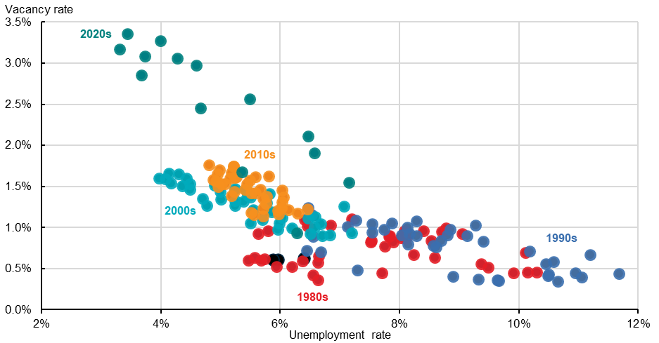
Source: Treasury analysis of ABS Job Vacancies and ABS Labour Force Survey. Seasonally adjusted figures.

- Matching efficiency in the Australian labour market
Job vacancies and people looking for employment can coexist in the labour market. For example, a skills mismatch can occur when a job seeker does not have the skills required for an available job, or the job does not offer the required conditions or renumeration. A geographic mismatch occurs when the vacancy and job seeker are in different places and the job seeker is unable or unwilling to move.
- Unemployment and  vacancy rates | - Next-quarter job finding rate of unemployed people
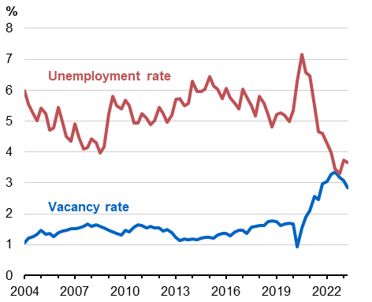 | 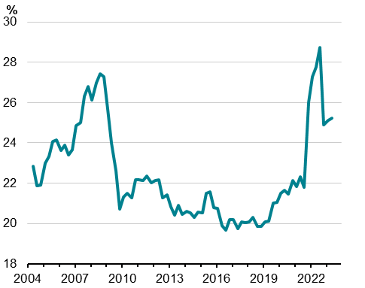
Source: ABS Labour Force Survey; ABS Job Vacancies.  Note: Original series. Vacancy rate interpolated between 2008–09. | Source: ABS Labour Force Survey.  Note: Four quarter rolling average.

Matching efficiency describes the rate at which people seeking work are matched to vacant jobs in a labour market. Poor matching efficiency reflects disconnects between the preferences, skills and location of potential workers, and the requirements, location, and renumeration of available jobs. A more efficient labour market will have lower rates of unemployment for a given level of vacancies. Improving matching efficiency in the labour market lowers the natural rate of unemployment, reduces labour and skills shortages, and increases potential output.
While matching efficiency is not directly measured in the economy, it can be estimated from measures of job vacancies, job seekers and job finders. Job vacancies are a measure of labour demand. The ABS Job Vacancies series counts vacancies available for immediate filling, and the series is correlated with near-term future employment growth. The vacancy rate was the highest on record in 2022, almost double previous peaks (Chart 2.1).
Job seekers are all people who are seeking work. It is usually measured by the unemployment rate, which is near a historic low (Chart 2.1). The ratio of vacancies to job seekers in a given period is a measure of labour market tightness. A tighter labour market indicates there are more vacancies for each unemployed person, and a looser labour market means there are more unemployed people for each vacancy. Job finders are people who have a job in the current period and were seeking a job in the previous period (Chart 2.2).
  - Unemployed matching efficiency
This paper measures matching efficiency over time using the job finding rate of unemployed people relative to what would have been expected based on current labour market tightness (the ratio of vacancies and unemployed). If job finding rates are unusually high (low), matching efficiency is considered to be similarly high (low). This approach follows Consolo and de Silva (2019), which is explored in more detail in Appendix A.
Matching efficiency of unemployed job seekers was high in the pre-GFC period between 2004 and 2009 (Chart 2.3). This period had decreasing unemployment, rising job vacancies, and high job-finding rates for short-term unemployed. Job-finding rates were 1–3 percentage points higher than expected for the level of labour market tightness. This period saw lower numbers of long-term unemployed, who tend to have about half the job finding probability of short-term unemployed (Chart 2.4).
- Matching efficiency  Matching efficiency relative to long-run average | - Job finding probability  Share unemployed who find work in the next month
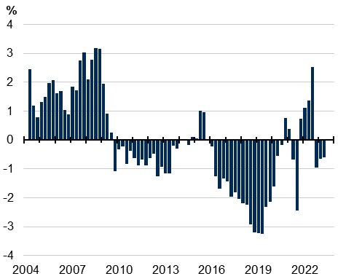 | 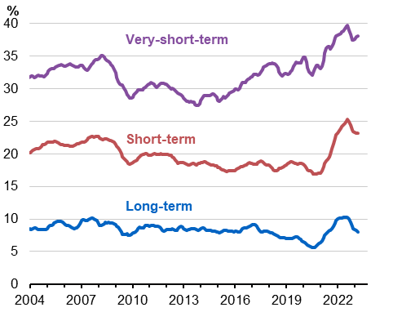
Source: Treasury analysis, see Appendix A.  Note: Four quarter average. | Source: Treasury analysis of ABS Labour Force microdata.  Note: Four quarter average. Very short-term unemployed is less than 4 weeks; short is 1‍–‍12 months; long-term is >12 months.

Matching efficiency was low between 2010 and 2019. Labour market tightness had a partial rebound after falling in 2009, but job finding rates remained below pre-GFC peaks across all unemployment groups. Despite increasing labour market tightness from 2015, job-finding probabilities remained relatively low. This was driven by lower job-finding rates of long-term unemployed, which made up a larger share of the unemployed pool. Matching efficiency has been improving since 2019. Matching efficiency started improving before the onset of the pandemic. Irregular labour market conditions during 2020 caused measured matching efficiency to be unstable. A tight labour market in the recovery from the pandemic has been matched by rising job-finding rates for unemployed people. Unemployed people were more likely to find work in 2022 than at any point since data began in 2004. This was true for short, long, and very long-term unemployed people.
  - Matching trends are clearer when more job seekers are considered
People classified as unemployed are not the only people who seek and find work. In addition to unemployed job seekers, there are job seekers who are not in the labour force (NILF). These are people who are not classified as unemployed but can be actively, passively, or not seeking employment when previously surveyed. These NILF sub-groups are identified using ABS Labour Force microdata (see Appendix A).
The first extension expands the scope of job seekers to include all non-working job seekers (Chart 2.5).
- Matching efficiency with non-working job seekers  Matching efficiency relative to long-run average | - Matching efficiency with all job seekers  Matching efficiency relative to long-run average
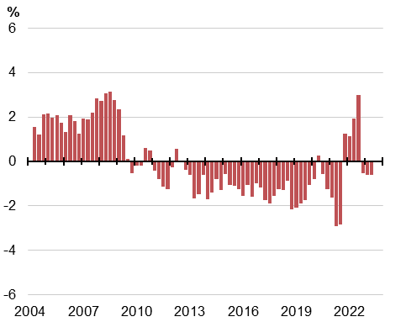 | 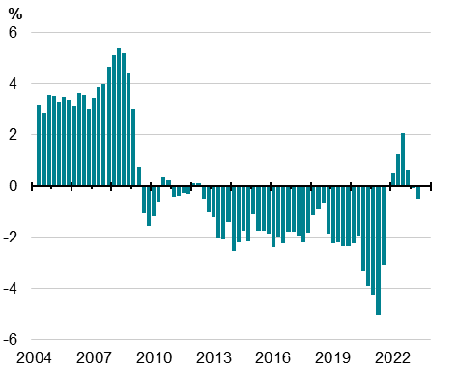
Source: Treasury analysis of ABS Labour Force and ABS Job Vacancies. See Appendix A. | Source: Treasury analysis of ABS Labour Force and ABS Job Vacancies. See Appendix A.

When including all non-working job seekers this analysis finds better matching efficiency rates between 2009–2013, driven by higher rates of NILF job seekers finding employment. This trend reversed in subsequent years, pushing matching efficiency lower.
Employed job seekers – workers who are looking for their next job – are also a large source of new matches in the economy and can be identified using ABS Labour Force microdata. Adding employed job seekers, the working and non-working matching efficiency rates were stronger before 2010, and weaker between 2010 and 2021 (Chart 2.6). This follows trends in job-to-job transitions in the labour force, which were high and rising until 2009. They then remained persistently low until recovering from the end of 2021.
Trends in matching efficiency are relatively clear. Matching efficiency in the Australian labour market started to improve in 2022 after a decade-long slump from 2008–2021. This means that unemployed are finding work faster on average, after accounting for the time of year, vacancy rate and unemployment rate, demonstrating that businesses are doing a better job at finding new employees among the available pool of workers. Increased matching efficiency has been driven by all job seeker groups – unemployed, NILF and employed. Two additional components of labour market matching – skills and geography – will be explored in following sections.

- Skill level variation in labour market tightness and occupation movements
Analysis of aggregate levels of labour demand (job vacancies) and labour supply (job seekers) is useful for identifying cyclical trends at the national level. However, the Australian labour market is not a single, homogenous market. For example, a nurse vacancy in Perth is unlikely to be filled by an unemployed construction labourer in Cairns, and high unemployment rates of construction labourers in Cairns are unlikely to fall by hiring more nurses in Perth. This section explores skill level and occupational labour market matching.
  - Exploring skilled labour markets within Australia
The identification of specific labour markets can help us understand sources of mismatched supply and demand across skill and geographic lines and inform labour market policy decisions. To explore the labour markets that exist beneath the aggregate requires measuring job vacancies and job seekers along common dimensions, when:
- Vacancies only have characteristics associated with a particular job, such as an occupation, an industry, a location and an advertised wage, and
- Job seekers have characteristics only associated with a person, such as: age, sex, a level and field of education, a location of residence, and – for those who have been recently employed – an occupation and industry of their previous job.
This analysis uses a job vacancy’s occupation and individual job seeker education level and previous occupation to explore labour supply, demand, and matching levels by skill levels. Three skill groupings are used – low, middle and high – which correspond to occupation skill and education levels. The exact methodology is outlined in Appendix B.
This classification allows for people working in high (or middle) skill occupations to be classified as high (or middle) skill workers, regardless of their education, to reflect skills developed through workforce experience. The inclusion of education allows for people without a current or previous occupation, such as new entrants to the workforce or those coming back from extended periods of leave or long-term unemployment, to be classified by their education level. This approach means that every person in the labour force can be assigned a skill level. However, due to data limitations before August 2015, this analysis is restricted to 2016 onwards.
Applying these skill level groupings to job vacancies and unemployed people in Australia shows distinct characteristics of high, middle and low-skill labour markets compared to the aggregate. Chart 3.1 shows unemployment rates and vacancy rates for each labour market. In the aggregate labour market (Panel A), as explored in Section 1, the vacancy rate rose slightly between 2016 and 2019, before dipping in 2020 with the onset of COVID-19. From mid-2020, vacancies rebounded before surpassing previous levels and now sit at about 3.5 per cent of labour demand (employment plus vacancies). The unemployment rate has moved broadly inversely to the vacancy rate.
The high-skill labour market (Panel B) tends to be tighter than the aggregate. Demand for high-skill occupations followed a broadly similar path to the aggregate trend, with a slightly lower vacancy rate (less than 2 per cent) before increasing to 2.3 per cent at the beginning of 2023. The high-skill group tends to have low unemployment rates, from about 3.5 per cent between 2016 and 2019 to less than 2 per cent in 2023. At the beginning of 2023 there were more vacancies for high-skill jobs than there were job seekers with high-skill occupations. However, low unemployment rates may overstate the level of matching efficiency in the high-skill labour market, as many people are employed in lower-skilled occupations (explored in the next section).
The middle-skill labour market (Panel C) is persistently looser than the high-skill group, with higher unemployment and marginally lower labour demand. However, the middle-skill labour market has tightened significantly over the past 2 years, in line with the aggregate labour market.
The low-skill labour market (Panel D) has higher rates of unemployment and higher rates of vacancies. The low-skill labour market has tightened significantly since mid-2020, with declining unemployment rates and rising vacancy rates. But within-skill level mismatch remains high, with about 7 per cent of the labour force unable to be matched to available jobs. In addition, low-skill job seekers also compete with some higher skilled job seekers, as explored in the next section.
        - Unemployment and vacancy rates by skill group
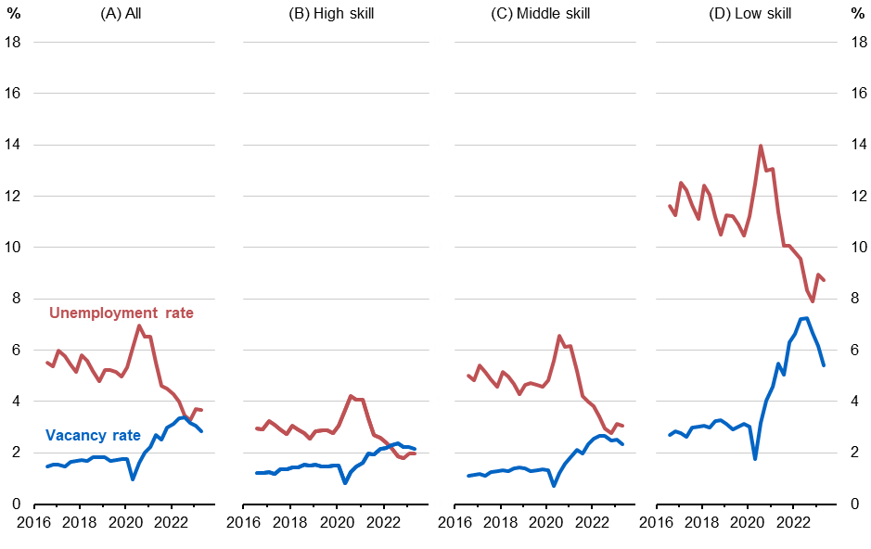
Source: Treasury analysis of ABS Longitudinal Labour Force Survey, ABS Job Vacancies, JSA Internet Vacancy Index. See Appendix B.

  - Skill level mismatch of workers can ‘crowd out’ lower-skill workers
Some degree of skill level mismatch will always exist in the labour force. Over education – where a worker is in an occupation that does not require their level of education – has increased alongside rising educational attainment. Sometimes people optimally choose a job that is different to their level of education and training, reflecting the personal preferences of workers. Other times it is undesirable, caused by temporary and structural factors that can have flow-on effects to others in the labour force.

Skill level misallocation may hint at some labour market challenges
Labour market tightness in the high-skill market sits alongside apparent between-skill mismatch. The mismatch between a worker’s education level and their occupation level is significant. Between 2016 and 2023, about 30 per cent of high-skill workers were employed in occupations classified as middle and low-skill. This is consistent with other research on over education in the Australian labour market. These occupations were often lower-skilled health and clerical or administrative roles (Chart 3.2). Over 40 per cent of middle-skill workers were employed in low-skill occupations, particularly as machinery operators and labourers.
Skill level mismatch can be the consequence of a more educated workforce. There has been significant growth in bachelor and postgraduate degree attainment over the past 40 years. About 40 per cent of 25 to 34-year-olds had a bachelor’s degree or above in 2020 (up from 10 per cent in 1980). Over education can be temporary or reflect other compensating factors, such as location or flexibility or lower pressure jobs.
Skills depreciation can also drive apparent skill level mismatch. The skills demanded within some occupations can change quickly. Workers who spend time away from the workforce or from a particular occupation can find themselves without the skills now required for their job, despite having the required level of education.
Job skill misclassification can occur when a particular job within an occupation requires more education than is typically required for that occupation. For example, the education and training requirements for a Hospitality Manager can vary according to the size and complexity of the organisation.
Geographic mismatch, where appropriately skilled jobs are not available in the region, can also lead job seekers to take up lower-skilled work. This type of mismatch is explored in Section 4.
        - Share of employees by skill
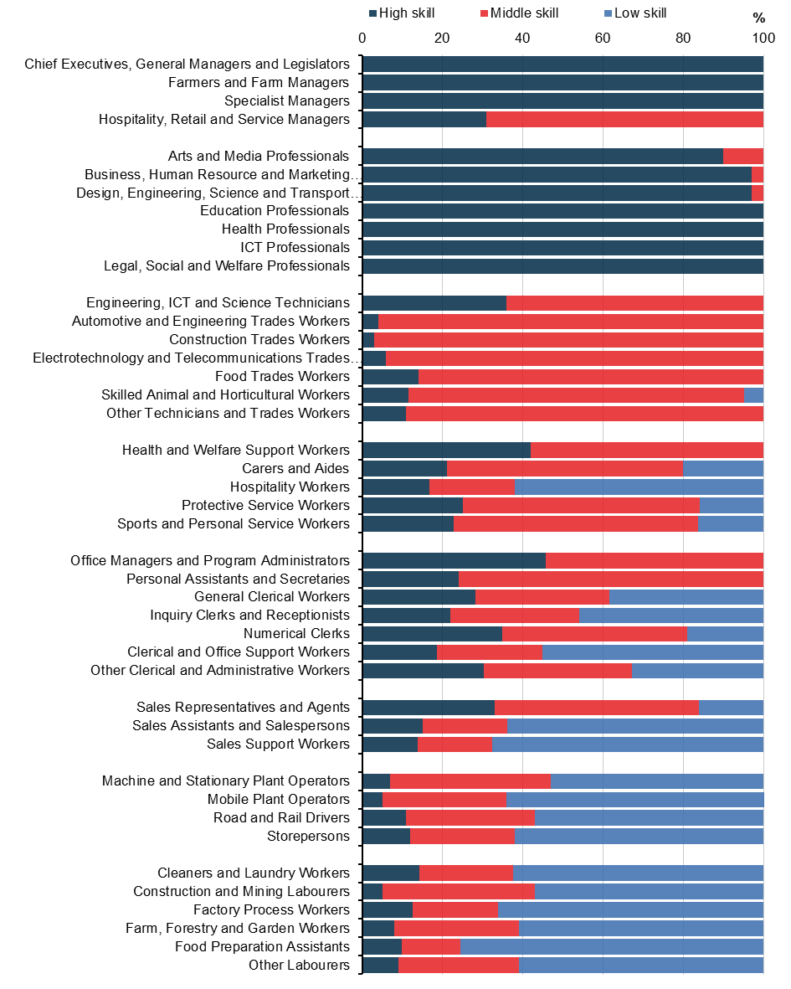
Source: Treasury analysis of ABS Longitudinal Labour Force Survey.
Note: Occupation is ANZSCO submajor, and skill level as defined in Appendix B. Data are pooled across 2016–2023.

Many people (re)enter the labour market in lower-skilled jobs
Skill level mismatch also means that low-skill job seekers have to compete with high and middle-skill job seekers for the same roles. Chart 3.3 on the following page shows the next quarter destination occupations for unemployed people without prior occupation information. This group contains young job seekers, about half of whom are entering the workforce for the first time. It also includes those who have been without an occupation for an extended period – such as those coming from periods of leave or long-term unemployment.
Low-skill workforce entrants are most likely to find employment in Sales Assistant (20 per cent) and Sales Support (6 per cent) roles; in Hospitality (12 per cent) and Food Preparation (10 per cent) roles; and as Cleaners (6 per cent), Drivers (5 per cent) and Other Labourers (5 per cent).
Middle-skill workforce entrants have access to a broader range of jobs, especially as Carer and Aides (13 per cent) and trades, such as Construction (5 per cent) and Automotive Engineers (5 per cent). However, middle-skilled workforce entrants also find work in lower-skilled occupations. For example, 6 per cent enter Sales Assistant roles, an occupation that typically does not require a qualification.
High-skill workforce entrants are more concentrated among education, health, and business professional roles. About a third of high-skill workforce entrants find work in lower-skilled occupations. These patterns follow the over education patterns (Chart 2.2), with lower-skilled health and administrative jobs being common.

Workers switch jobs across skill levels but within clusters
As with new entrants to the labour market, workers who switch jobs compete with unemployed people for vacancies. Much of this job switching is within the same occupation. There is some movement from one skill level to another when people switch occupations. Workers and job seekers have preferences, foundational skills, and specialised skills required for occupations that shape the roles they look for in the labour market.
Preferences for the type of work a person wants to pursue develop over time and are affected by factors including socio-economic status, occupational segregation (such as by sex), and macroeconomic conditions during childhood.
Foundational skills developed through education and workplace experience – such as communication, teamwork and problem solving – are common across a range of occupations and can allow workers to switch occupations.
        - Unemployment to employment transition rates for people with no prior occupation
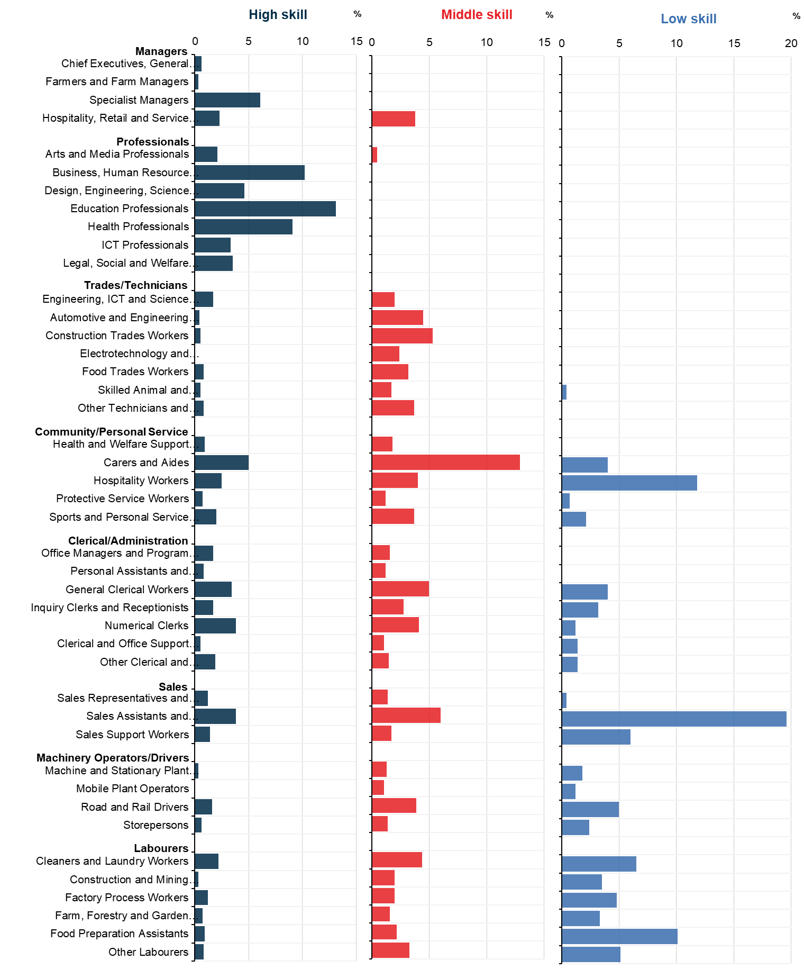
Source: Treasury analysis of ABS Longitudinal Labour Force Survey.
Note: Occupation is ANZSCO Submajor, and skill level group is defined in Appendix A. Data are pooled across 2016 to 2023.

Specialised skills can be specific to a particular job, occupation or industry. These skills tend to be developed over long periods – through education, training and work experience – and tend to be less transferable than foundational skills. For example, a school teacher is unlikely to have the skills to take up a job as a registered nurse, despite the same education level and similar foundational skill requirements. However, some occupations overlap in specialised skills. While numerical clerks, business professionals and chief executives are distinctly different occupations, they all require numerical skills.
Preferences, foundational and specialised skills interact to form clusters of occupational transitions in the labour market. These clusters can be explored using a transition matrix of job changes. Case studies are presented in Chart 3.4 to illustrate the patterns of within/between occupation transitions.
- Of business professionals who begin with a new employer, about a third move into specialised management roles, while 15 per cent remain as business professionals. There is some transition within the professional environment, particularly into design IT and education. A smaller share move to lower-skilled occupations that require skills developed in business, such as numerical clerks and office administrators.
- Of health professionals who begin with a new employer, almost 40 per cent stay within the health professional occupation. For those who move, the most common destination is to specialist management. There is also some down-skilling, with moves most likely to health and welfare support, and carer occupations.
- Automotive engineers are the most likely to stay within their occupation of these case studies, with about half remaining as automotive engineers after a move to a new employer.
- Carers and aides also have relatively high within-occupation retainment. New occupations tend to be to health and support workers, or to higher skilled occupations as education or health professionals.
- Construction and mining labourers tend to move to other manual occupations, with about two-thirds moving to similar labourer jobs, such as factory or forestry workers, or to machine operators and driver occupations. About 20 per cent move to trades occupations that tend to require qualifications, particularly construction trades.
Between-skill mismatch means that significant shares of high- and middle-skill workers are in occupations that may not make best use of their skills. While most entrants to the workforce find work aligned with their skill levels, many high- and middle-skilled job seekers find work in lower-skilled occupations. Geographic mismatch – job opportunities and job seekers being in different regions – can play a significant role in the efficient working of the labour market. This is explored in the next section.
        - Select occupation-to-occupation transitions
Destination occupations (rows) as a share of newly employed original occupations
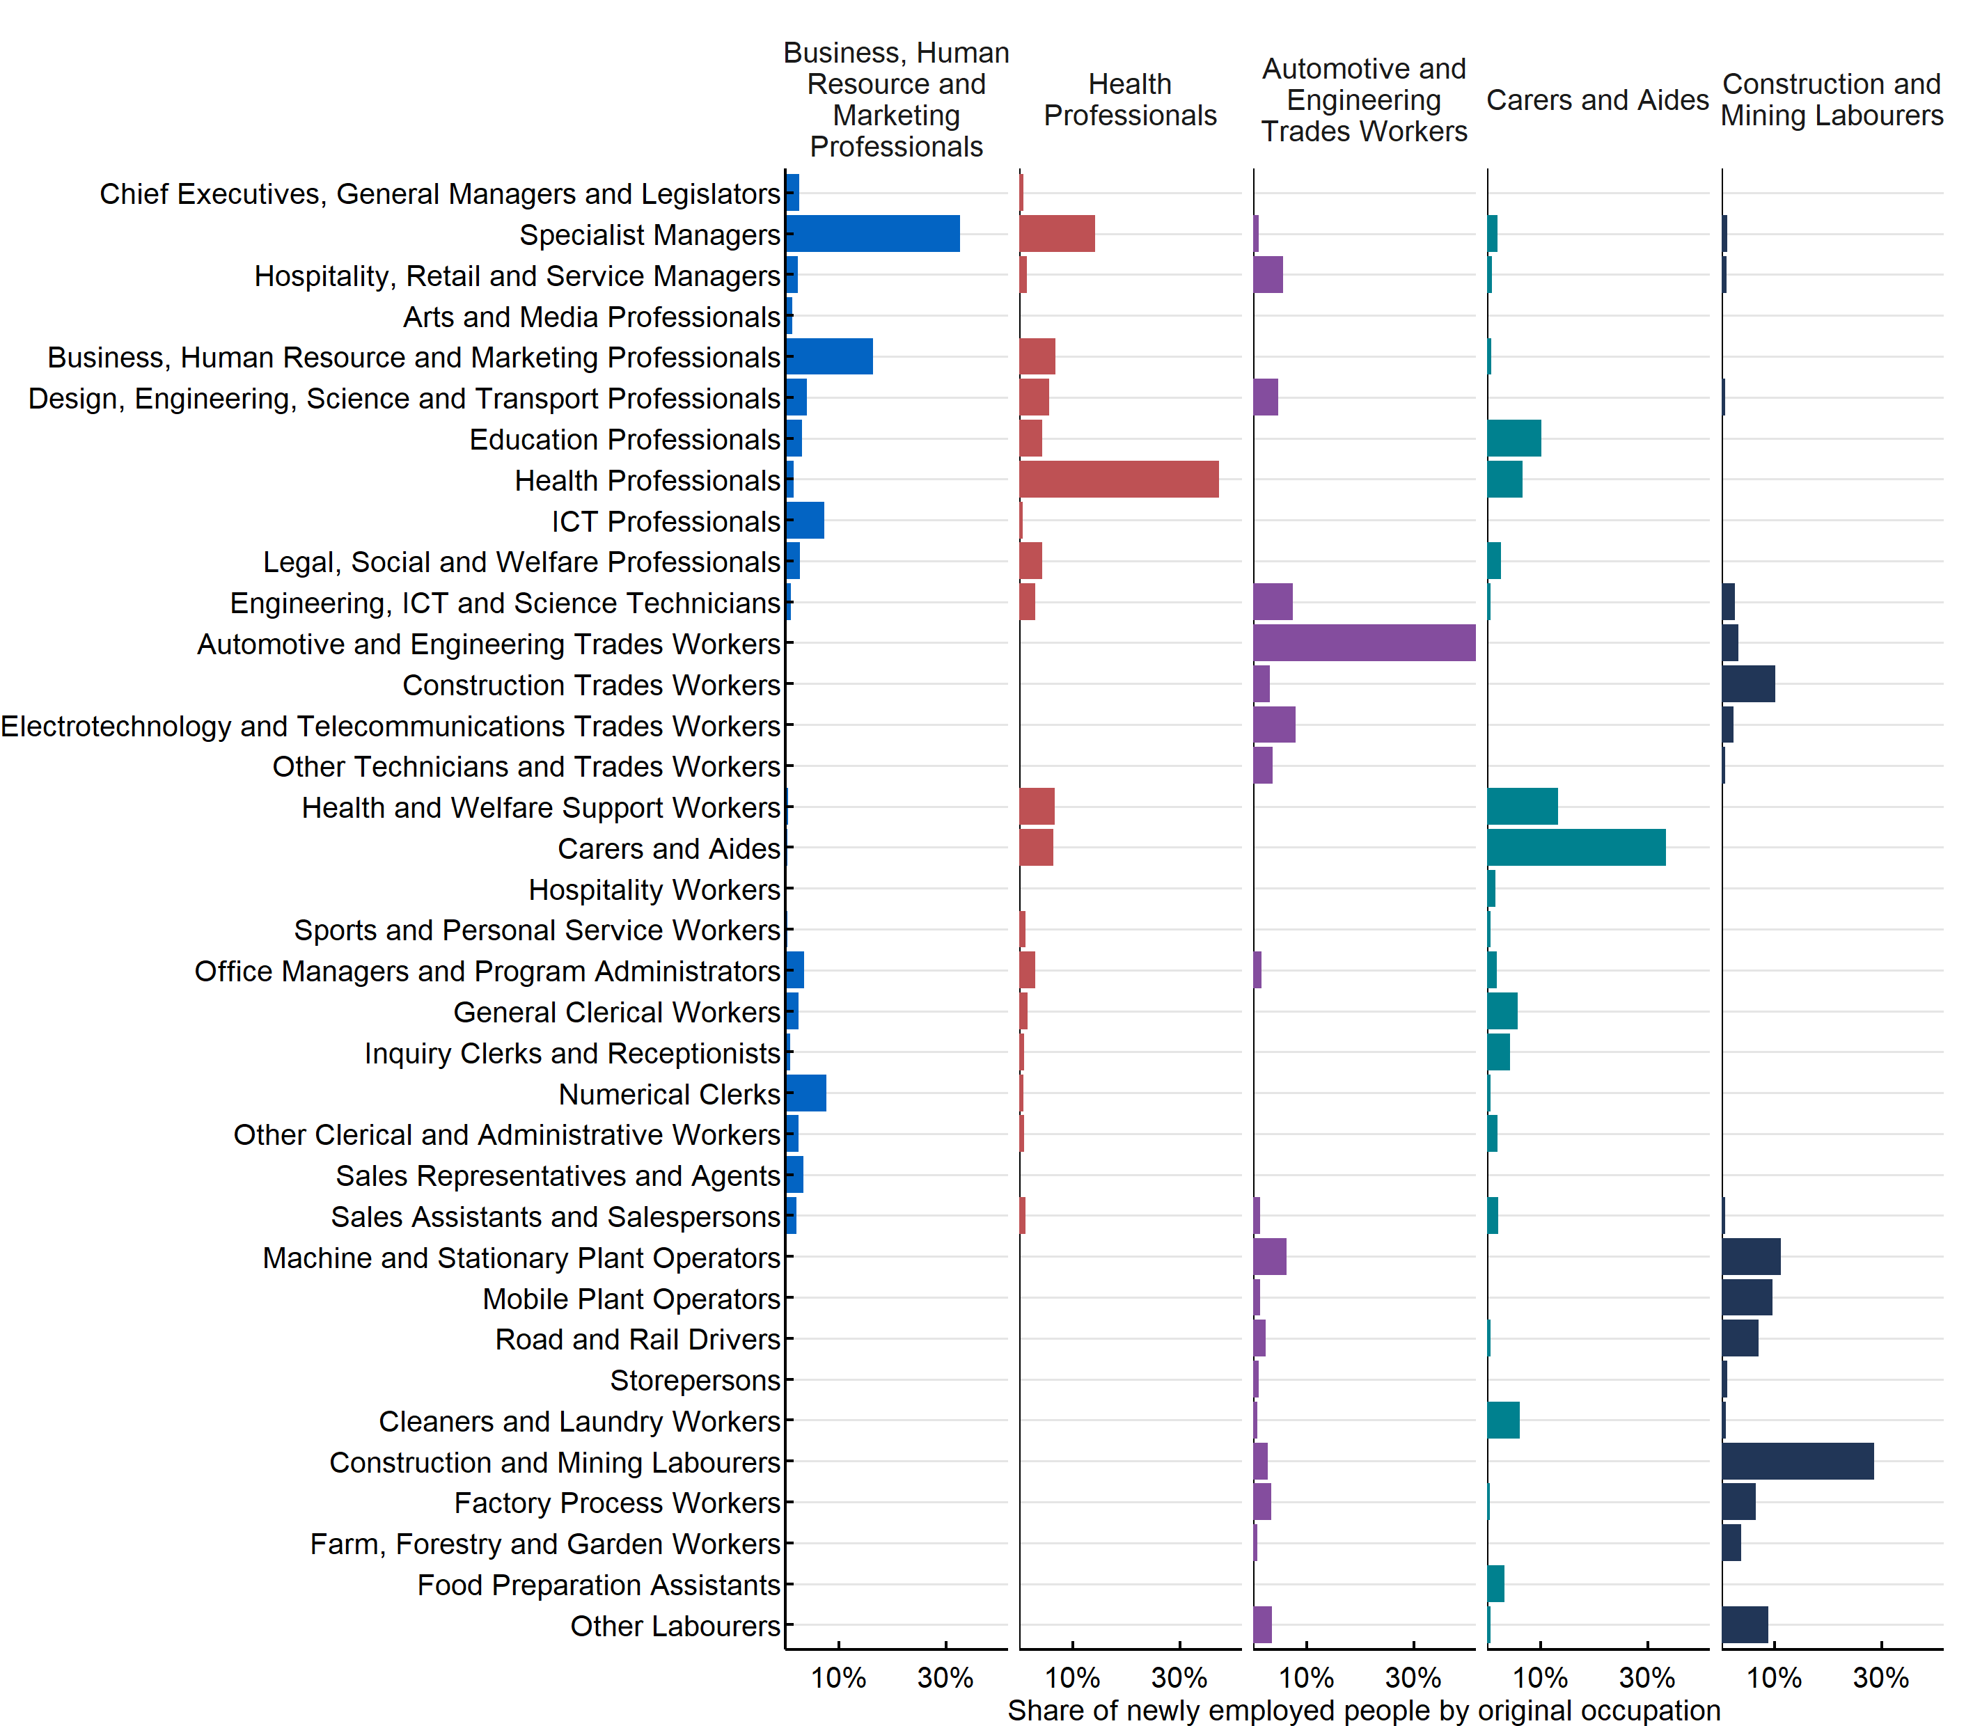
Source: Treasury analysis of ABS Longitudinal Labour Force Survey, ABS Job Vacancies, JSA Internet Vacancy Index.

- Regional variations in labour market tightness and matching by skill level
  - Exploring labour markets by skill and region
Australia is not a single homogenous labour market. Many factors drive local labour demand and supply within regions. This means labour market conditions can vary significantly. Cyclical and structural forces can have different effects on labour demand in regions based on their industrial composition. Labour supply can respond differently based on its skills mix and demography.
Australia is a large country and geographic mismatch – job opportunities and job seekers being in different regions – can play a significant role in the efficient working of the labour market. As the majority of work is done in person, strong demand for labour in one corner of the country is unlikely to materially reduce unemployment in another corner. Geographic mobility can provide some solutions to this mismatch. However, this is not a viable option for all jobs or for all job seekers.
The analysis in this section examines the supply of and demand for skilled labour in each region in Australia. It identifies overall regional trends in tightness and mismatch by skill level, before examining a series of regional labour markets with distinctly different outcomes.

Geographic mobility is a partial solution to geographic mismatch
Geographic mismatch occurs when there are job seekers and appropriate job vacancies in different regional labour markets. Geographic mobility – workers coming to jobs, jobs coming to workers, or a mix of the two – is one tool to reduce geographic mismatch.
- Workers permanently moving to jobs: young people are more likely to move. There is also a higher propensity for geographic mobility among renters, unemployed and underemployed people. However, people are most likely to move within the same labour market because of housing or family reasons rather than work. People who are more established in an area – such as those with children and those who own their own home – are less likely to move. Long-term unemployed also face additional challenges in moving long distances in search of work.
- Workers moving to jobs via long distance commuting: for employers and employees who cannot or will not permanently move location, fly-in fly-out (FIFO) and drive-in drive-out (DIDO) provides an alternative pathway for managing geographical mismatch. This approach has been a defining characteristic of Australia’s mining booms with significant population shares of mining regions appearing to be FIFO workers. Long distance commuting is also playing a role in hybrid arrangements with remote work.
- Jobs moving to workers via remote work: remote work is an option in some jobs. This allows workers and jobs in different regions to be matched.

The region-skill Beveridge Curve
This analysis splits the labour market into 37 regions and 3 skill groups (used in Section 3) to explore 111 region-skill labour markets in Australia between 2016 and 2022 (see Appendix D).
These regions are used to allow the use of JSA Internet Vacancy Index data by region and can provide an overview of regional labour market characteristics. However, some regions span particularly large areas, meaning that some geographic mismatch remains even when looking at specific regions.
All quarterly observations for the region-skill labour market cells are presented in Chart 4.1. It shows that the high-skill group has persistently lower rates of unemployment for a given vacancy level than middle or low-skill groups. Across regions, low-skill groups tend to have higher unemployment and vacancy rates.
Low and middle-skill groups tend to be below the ‘$u=v$’ line (where vacancies equal unemployment). However, there are some outliers that sit above that line, with greater vacancies than unemployed within or across skill groups. These areas tend to be in smaller capital cities.
        - Beveridge curve by skill and geography, 2016–2022
Each point represents a quarterly observation of a skill group in a labour region. Log scales.
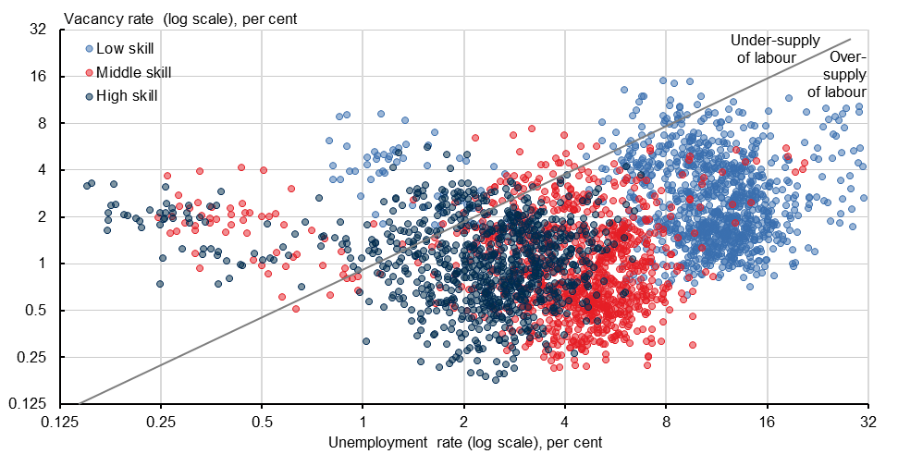
Source: Treasury analysis of ABS Longitudinal Labour Force Survey, ABS Job Vacancies, JSA Internet Vacancy Index.

  - Different labour market conditions across regions
The methodology developed across this, and the previous sections, allows us to measure labour market conditions over time for individual labour markets (within skills and within regions).
The analysis shows that a broad range of labour market conditions exist within Australia at any point. Case studies are presented in the figures below to illustrate these structural and temporary differences. The following figures show unemployment rates and vacancy rates for each region-skill labour market.

Sydney: Similar trends to national average
The Sydney labour market tends to have higher demand and similar unemployment levels to the national average. The overall vacancy rate (Panel A) was relatively flat between 2016 and 2019, before dropping quickly in 2020 and rebounding to surpass previous levels (Chart 4.2). The unemployment rate has moved broadly inversely to the vacancy rate.
The high-skill labour market (Panel B) tends to be tighter than the middle and low-skill labour markets. The middle-skill labour market (Panel C) is persistently looser than the high-skill group, with higher unemployment and lower labour demand. However, the middle-skill Sydney labour market has tightened significantly over the past 2 years, in line with the national labour market.
The low-skill labour market (Panel D) has higher rates of unemployment and higher rates of vacancies. Low-skill labour demand in Sydney grew rapidly since mid-2020. Unemployment rates followed, starting to decline from early 2021 and by 2023 were below pre-pandemic levels and rising vacancy rates. But within-skill level mismatch remains high, with about 8 per cent of the labour force unable to be matched to available jobs.
        - Sydney unemployment and vacancy shares by skill group
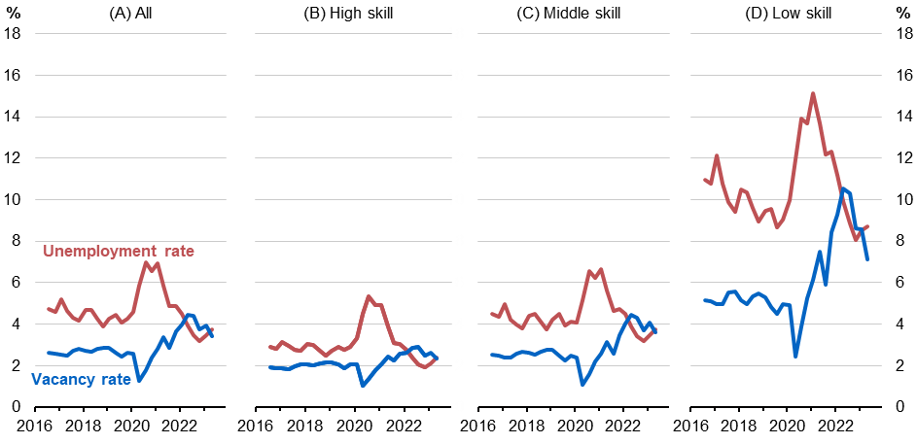
Source: Treasury analysis of ABS Longitudinal Labour Force Survey, ABS Job Vacancies, JSA Internet Vacancy Index.

Darwin: Persistent within-skill labour shortages
Darwin has had a tighter labour market than the national average, with about the same number of unemployed job seekers and job vacancies between 2016 and 2019 (Chart 4.3).
During this time, there was an excess of high-skill labour demand and an excess of low-skill labour supply. From 2022, the Darwin labour market has had a significant excess of labour demand. This trend has been seen across all skill levels.
While unemployment rates in Darwin are similar to national levels, vacancy rates are elevated across all skill groups. This indicates that more jobs and job seekers coexist in the same region within the same skill level, but face higher levels of within-skill mismatch. Darwin has had a persistent shortage of workers in across the 3 skill groups since 2021.
        - Darwin unemployment and vacancy shares by skill group
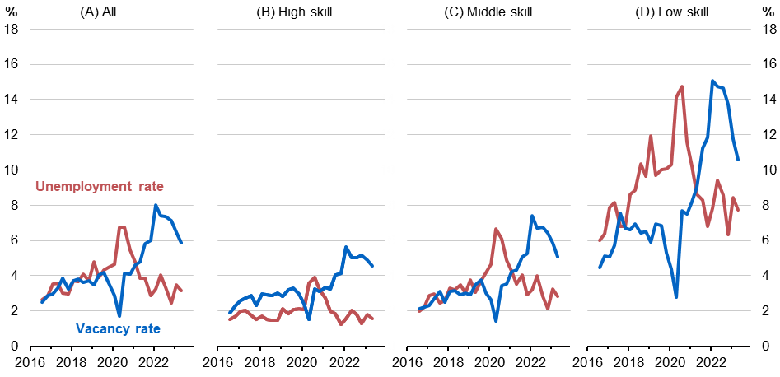
Source: Treasury analysis of ABS Longitudinal Labour Force Survey, ABS Job Vacancies, JSA Internet Vacancy Index.

Toowoomba and South West Queensland: Persistent loose labour market
Toowoomba and South West Queensland (Chart 4.4) had a persistently loose labour market between 2016–2023.
While unemployment tends to be lower for high-skilled groups, unemployment remains higher across all skill groups than the national average. People in the low-skill labour market have experienced particularly high rates of unemployment.
This is at least in part reflected in low levels of labour demand, with vacancies below national levels across skill groups, especially for low-skill occupations.
        - Toowoomba and South West Qld unemployment and vacancy shares by skill
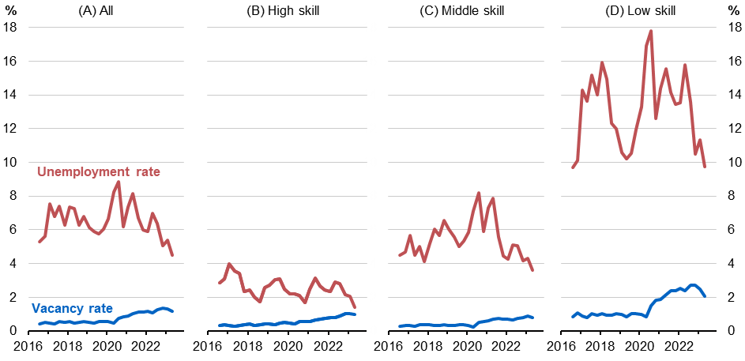
Source: Treasury analysis of ABS Longitudinal Labour Force Survey, ABS Job Vacancies, JSA Internet Vacancy Index.

Far North Queensland: Long-run tightening labour market
Far North Queensland (Chart 4.5) has an increasingly tight labour market with average levels of matching efficiency. Unemployment decreased from 2016–2022 across skill groups. Overall, the unemployment rate has declined from about double the national rate to the national rate in 6 years.
The unemployment rates of low-skill workers were above 18 per cent in 2016 and have progressively decreased to below 8 per cent by the end of 2022. The reduction in unemployment has been allowed by rising demand for labour over this period across all skill levels.
        - Far North Queensland unemployment and vacancy shares by skill group
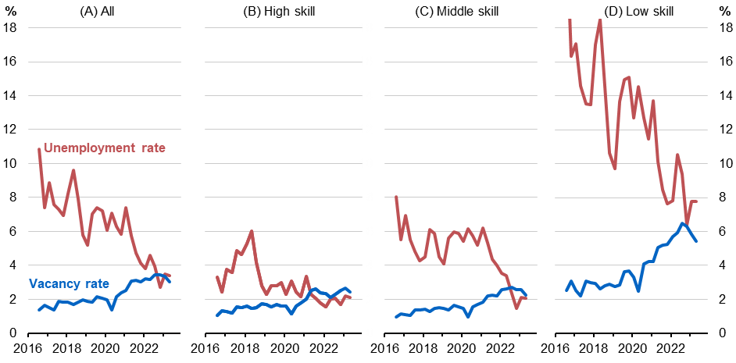
Source: Treasury analysis of ABS Longitudinal Labour Force Survey, ABS Job Vacancies, JSA Internet Vacancy Index.

  - Summary
Australia is made up of heterogenous labour markets, each of which can have different levels of mismatch and labour market tightness. Some regions experience acute labour or skills shortages at the same time others have persistently high rates of unemployment. However, much of Australia’s labour market mismatch is within region and skill groups. In many regions, including in most major cities, labour supply and demand is currently close to parity. Low-skill regional labour markets in particular demonstrate high levels of unemployment and high levels of job vacancies, suggesting within-region, within-skill group matching efficiency needs to improve to further reduce unemployment.

Appendices
  - Modelling matching efficiency
This paper estimates aggregate matching efficiency following Consolo and de Silva (section 3, 2019). This approach specifies the matching function as a constant returns to scale Cobb-Douglas function of the vacancy rate and the unemployment rate.
Following their approach, the aggregate matching function is estimated by looking at quarterly job finding probabilities and labour market tightness (the vacancy-unemployment ratio), with matching efficiency defined as the time-varying residual from estimating a reduced form matching function. An adjusted version of the Consolo and de Silva (equation 1, 2019) model is:
$$M_{t}=β_{0}+β_{1}θ_{t}+ β_{2}θ_{t}^{2}+q_{t}+ε_{t}; θ_{t}=\frac{v_{t}}{js_{t}} \text{and} M_{t}=\frac{H_{js,t}}{js_{t-1}} \text{(1)}$$
where matching probability $M_{t}$ is the share of job searchers the previous period $js_{t-1}$ who found a job in the current period, $H_{js,t}$. Labour market tightness, $θ_{t}$, is the ratio of job vacancies $v_{t}$and job searchers, $js_{t}$. $q_{t}$ is a control for quarter to account for regular seasonal effects. The residuals, $ε_{t}$, can be interpreted as a measure of matching efficiency in the current period. In what follows, we describe our implementation of this approach in the Australian setting.
For all models, the period is quarterly and the measure of vacancies in the economy is ABS Job Vacancies. Different measures of job searchers (and, therefore, matching probability) are explored in 3 models:
- Unemployment model: the unemployment model follows a standard Beveridge Curve framework – and that used in Consolo and de Silva (2019) – by defining job searchers as unemployed people, $js_{t}=u_{t}$. Unemployment data is sourced from the Labour Force Survey.
- Non-workers model: expands the definition of job searchers to include NILF job seekers, ${js_{t}=u_{t}+ns}_{t}$. Three groups are considered to be possibly searching for employment within the NILF cohort: those actively searching for work, those passively searching for work, and those not searching for work. ABS Longitudinal Labour Force microdata is used to determine how many of each group enter employment in each period. The number of job searchers in each group is defined as the number of job finders divided by the hiring rate of the actively looking group.
- Workers and non-workers model: adds employed job searchers to the non-workers model, including all job searchers in the labour market: $js_{t}=u_{t}+{ns}_{t}+{es}_{t}$. ABS Longitudinal Labour Force microdata is used to count the number of new hires from the employed pool, measured using the share of previously employed workers who have been in their current job for less than 3 months. The share of job searchers who are seeking work at any point is assumed to be fixed at 10 per cent.

  - Defining skill level groups
This analysis defines skill levels to match vacancies (which have occupations) and unemployed people (who have education levels and, often, a previous occupation).

Method
In this analysis, skill level is defined as one of 3 exclusive and exhaustive groups:
- High skill: Bachelor’s degree or above required, ABS skill level 1
- Middle skill: Cert III/IV or diploma required, ABS skill level 2 or 3
- Low skill: High school or Cert I/II required, ABS skill level 4 or 5.
A job vacancy’s skill group is defined by the ABS skill level of its ANZSCO occupation. A person’s skill group is defined by their highest level of education or the skill level of their current or previous job.
- Education level is important to define the skill levels of people without information on their previous occupation. This group is largely made up of young job seekers, about half of whom are entering the workforce for the first time. It is also comprised of those who have been without an occupation for an extended period, such as those coming from periods of leave or long-term unemployment. Education information has only been collected for each rotation group in the ABS Longitudinal Labour Force since August 2015.
- Note that as people are classified by the highest education and occupation skill level, this style of analysis cannot identify ‘under skilled’ workers. By definition a worker without a bachelor’s degree working in a high-skill occupation that would usually require a bachelor’s degree is classified as high skill.

Data
- Skill level vacancy shares are taken from the JSA Internet Vacancy Index (by ABS skill level and state), with state shares scaled to state job vacancy levels from ABS Job Vacancies.
- Skill level employment and unemployment shares are generated from ABS Longitudinal Labour Force microdata using an individual’s highest level of education and ABS skill level of their current or previous occupation. ABS skill levels and education levels are then assigned a high, middle or low-skill grouping according to the method described above.
- Skill level shares are scaled to publicly available employment and unemployment counts from the ABS Labour Force Survey (original series, not seasonally adjusted).

  - Occupation transition matrices
ABS Longitudinal Labour Force microdata is used to explore changes in ANZSCO sub-major occupation for individuals from one quarter to the next. These labour force transition matrices allow us to see where all people, including unemployed people and those without a previous occupation, tend to gain employment by occupation when commencing a new job. All transitions observed between 2016 and 2022 are pooled to generate the matrix to avoid sample size issues.
Chart C.1 on the following page shows the full transition matrix.

          - Occupation transitions for people commencing new jobs
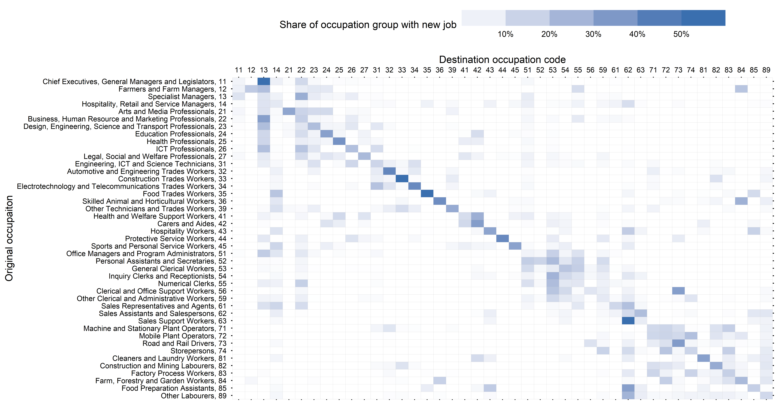
Source: Treasury analysis of ABS Longitudinal Labour Force Survey.
Note: Pooled quarterly transitions between 2016–2022.

  - Defining region-skill groups
This analysis defines regions and skill levels to match vacancies (which have locations and occupations) and unemployed people (who have locations, education levels and previous occupations).
This analysis splits labour market into 37 regions with 3 skill groups (111 cells) to explore varied conditions. Regions are defined by JSA Internet Vacancy Index (IVI) Regions. Labour force data is sourced from the ABS Longitudinal Labour Force microdata at Statistical Area 4 (SA4) level before being corresponded to IVI regions. JSA provides a correspondence tables of SA4 regions to IVI regions.
These regions are shown in Chart D.1.
          - Internet Vacancy Index regions
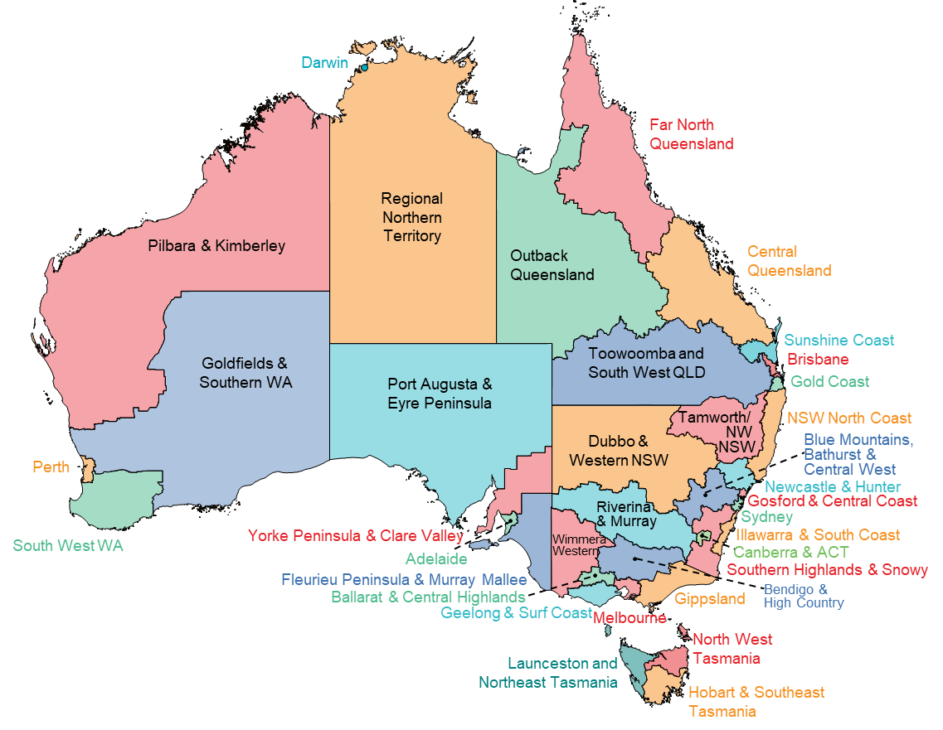
Source: Jobs and Skills Australia (2023).

References
Australian Bureau of Statistics. (2022). Classifications: Conceptual Basis of ANZSCO. https://www.abs.gov.au/statistics/classifications/anzsco-australian-and-new-zealand-standard-classification-occupations/2022/conceptual-basis-anzsco#underlying-concepts
Ahn, H. & Crane, L. (2020). Dynamic Beveridge Curve Accounting, Federal Reserve. https://www.federalreserve.gov/econres/feds/dynamic-beveridge-curve-accounting.htm
Borland, J. (2011). The Australian Labour Market in the 2000s: The Quiet Decade. Reserve Bank of Australia Annual Conference 2011. https://www.rba.gov.au/publications/confs/2011/pdf/borland.pdf
Consolo, A. & da Silva, A. (2019). The euro area labour market through the lens of the Beveridge curve. European Central Bank, Economic Bulletin Issue 4/2019. https://www.ecb.europa.eu/pub/economic-bulletin/articles/2019/html/ecb.ebart201904_01~9070de27a0.en.html
Cotofan, M., Cassar, L., Dur, R., & Meier, S. (2023). Macroeconomic Conditions When Young Shape Job Preferences for Life. The Review of Economics and Statistics 2023; 105 (2): 467–473. doi: https://doi.org/10.1162/rest_a_01057
D’Arcy, P., Gustafsson, L., Lewis, C., & Wiltshire, T. (2012). Labour Market Turnover and Mobility. RBA Bulletin December Quarter 2012. https://www.rba.gov.au/publications/bulletin/2012/dec/pdf/bu-1212-1.pdf
Deming, J. (2017). The Growing Importance of Social Skills in the Labor Market. The Quarterly Journal of Economics, 132 (4): 1593–1640. https://doi.org/10.1093/qje/qjx022
Deming, D., & Noray, K. (2020). Earnings Dynamics, Changing Job Skills, and STEM Careers. The Quarterly Journal of Economics, 135 (4): 1965–2005. https://doi.org/10.1093/qje/qjaa021
Deutscher, N. (2019). Job-to-job transitions and the wages of Australian workers. Treasury Working Paper 2019-07. https://treasury.gov.au/sites/default/files/2019-11/p2019-37418-jobswitching-v2.pdf
Figura, A. & Waller, C. (2022). What does the Beveridge curve tell us about the likelihood of a soft landing? Federal Reserve. https://www.federalreserve.gov/econres/notes/feds-notes/what-does-the-beveridge-curve-tell-us-about-the-likelihood-of-a-soft-landing-20220729.html
Gore, J., Holmes, K., Smith, M. et al. (2015). Socioeconomic status and the career aspirations of Australian school students: Testing enduring assumptions. Aust. Educ. Res. 42: 155–177. https://doi.org/10.1007/s13384-015-0172-5
Heath, A. (2020). Skills, Technology and the Future of Work. Reserve Bank of Australia. https://www.rba.gov.au/speeches/2020/sp-so-2020-03-16.html
Jobs and Skills Australia. (2022). State of Australia’s Skills: now and into the future. https://www.jobsandskills.gov.au/sites/default/files/2022-02/State%20of%20Australia%27s%20Skills%20Overview.pdf
Jobs and Skills Australia. (2023). Australian Skills Classification. https://www.jobsandskills.gov.au/australian-skills-classification
Norton, A., Cherastidtham, I., & Mackey, W. (2019) Risks and rewards: when is vocational education a good alternative to higher education?. Grattan Institute. https://grattan.edu.au/wp-content/uploads/2019/08/919-Risks-and-rewards.pdf
Petrongolo, B., & Pissarides, C. (2001). Looking into the Black Box: A Survey of the Matching Function. Journal of Economic Literature, 39 (2): 390–431. doi:10.1257/jel.39.2.390
Productivity Commission. (2014). Geographic Labour Mobility. Research Report, Canberra. https://www.pc.gov.au/inquiries/completed/labour-mobility/report/labour-mobility.pdf
Richardson, S. (2007) What is a skill shortage?. National Centre for Vocational Education Research https://www.ncver.edu.au/__data/assets/file/0019/7282/what-is-skill-shortage-4022.pdf
Whelan, S. & Parkinson, S. (2017). Housing tenure, mobility and labour market behaviour: Inquiry into housing policies, labour force participation and economic growth. AHURI Final Report No. 280, Australian Housing and Urban Research Institute Limited, Melbourne. http://www.ahuri.edu.au/research/final-reports/280

Thanks to Professor Jeff Borland, Stephanie Parsons, Josh Hickson, Nathan Deutscher, Omid Mousavi, Phoebe Wilk, Oscar Lane, as well as other staff from Treasury and Jobs and Skills Australia, and participants at the Australian Conference of Economists, for their thoughtful feedback and supporting analysis for this paper. The views expressed are those of the authors and do not necessarily reflect those of the Australian Treasury or the Australian Government.
A more detailed conceptualisation of labour market skills and skills shortages are outlined in Richardson (2007).
The Beveridge Curve is the relationship between job vacancy and job seeker rates. Key Beveridge Curve concepts are also explained in Figura and Waller (2022); Jobs and Skills Australia (chapter 5, 2021); Anh and Crane (2020); Consolo and de Silva (2019); Borland (chapter 11, 2011).
About twice as many people move from being outside the labour force to employment each period than move from unemployed to employed. Capturing this group provides a fuller picture of matches and job searchers in the Australian labour market.
Treasury analysis of ABS Labour Force microdata. See Deutscher (2019) for further discussions of job-to-job transitions.
This definition of ‘skill’ is common in the literature and is used by the ABS to form its occupational skill level framework: ABS (2022). However, this definition of skill does not include or measure the full range of skills and abilities required by occupations, or for specific jobs within occupations, or those performed by individuals within their job. Jobs and Skills Australia (2023) provides detailed descriptions of specific skills that are required for individual occupations in its Australian Skills Classification. See Richardson (2007) for a detailed discussion of labour market skills.
Alternative approaches that rely solely on a person’s previous occupation to determine their skill level are unable to classify a significant share of the job seeker pool, particularly long-term unemployed and new entrants to the workforce.
Heath (Graph 11, 2020). While education and occupation skill level definitions of skills mismatch are presented in this paper, Treasury analysis of HILDA data also finds that about 25 per cent of people with post-secondary qualifications self-report that their skills are not well utilised in their current job.
Rates of vocational attainment have remained flat over this period at about 35 per cent. Norton, Cherastidtham and Mackey (Figure 1.1, 2019).
Deming and Noray (2020) demonstrate this effect in the United States, showing that skill obsolescence lowers the income returns to work experience in faster-changing occupations.
For example, these preferences are affected by: socio-economic status during childhood, Gore (2015); by macroeconomic conditions when growing up, Cotofan, Cassar, Dur & Meier (2023); and by gender stereotypes and highly segregated occupations, Women’s Budget Statement (pp 28–30, 2023).
The importance of these foundational skills in a changing labour market is outlined by the National Skills Commission (pp 146–151, 2021). An examination of the growing importance of – and returns to – social skills in the labour market is explored in Deming (2017).
The similarity of occupations by specialised skills are explored in the Jobs and Skills Australia Australian Skills Classification (2023).
Administrative data published by the ABS (2023).
Whelan and Parkinson (2017); Productivity Commission (Chapter 7, 2014).
Productivity Commission (Chapter 7, 2014). The Productivity Commission also noted that ‘longer distance moves for the purpose of finding work are likely to be challenging for many long-term unemployed people due to lower levels of education and skills, poorer health, less access to affordable transport and greater reliance on family networks for support’ (p 147).
D’Arcy, Gustafsson, Lewis and Wiltshire (2012).
For more detail about how this approach fits into the Beveridge Curve framework, see Consolo and de Silva (Box 2, 2019); Petrongolo and Pissarides (2001); and Figura and Waller (2022).
The authors show that in the European context from 2000, the reduced form matching function approach reveals similar matching efficiency estimates to an alternative measure derived by estimating the elasticity between vacancies and unemployment: Consolo and de Silva (equation 2 and chart 5, 2019).
A polynomial term $θ^{2}$ is added to account for potential non-linearity in the relationship between labour market tightness and job finding probability. The findings in this paper are robust to the removal of this term.
ABS Job Vacancies (Australia: Table 1; and states: Table 2). Job vacancy data was not collected between August 2008 and August 2009 and is linearly interpolated for analysis conducted in this paper.
ABS LFS, Table 1. Original series are used. State-based analysis also uses this model, with data coming from Table 12. Job finding probabilities of unemployed people is sourced from ABS LFS Flows into and out of employment (GM1).
Treasury research by Parsons and Hickson (2022) [unpublished] shows the ‘not looking for work’ NILF group is the largest group, accounting for just under half of the whole NILF group. Those who are retired or permanent unable to work, the second largest NILF group, are excluded. This group has very low levels of job finding.
The intuition is that a NILF person will move from ‘not looking’ or ‘passively looking’ to ‘actively looking’ before finding a job, even if they are only ever measured as being ‘not looking’ in one period and ‘employed’ in the next.

