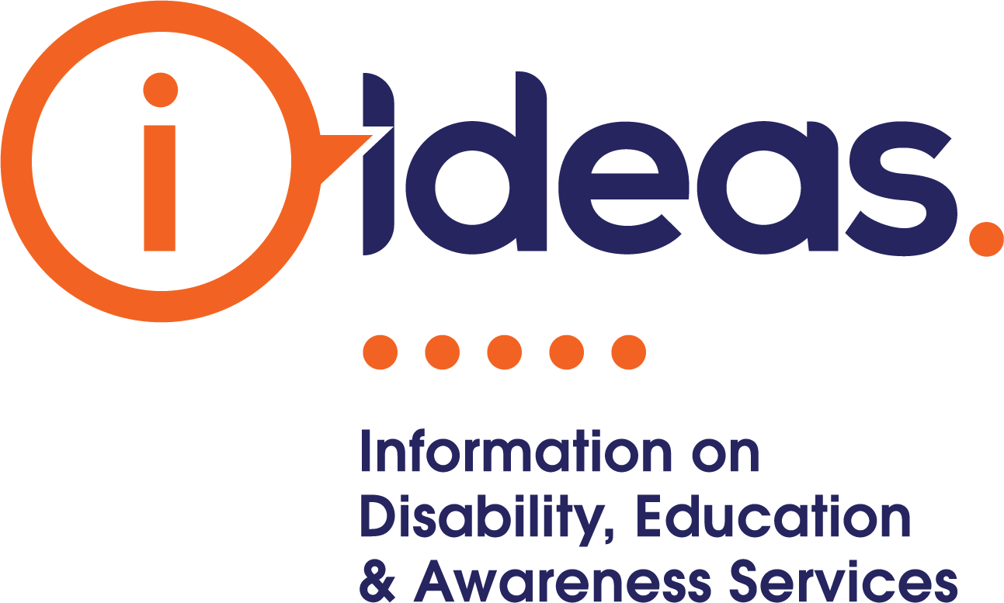

2020 Federal Budget Submission
Delivering the National Disability Information Gateway (NDIG)

December 2019

Contact: Diana Palmer
Executive Officer
E. mgr@ideas.org.au
M. 0407 419 737

IDEAS stands ready NOW to deliver the government’s election promise of a National Disability Information Gateway (NDIG).

IDEAS endorse the Government’s plan, released prior to the last federal election, to establish a NDIG to support all people with disability. IDEAS met with, briefed, and consulted with the then Minister for Families and Social Services, Hon Paul Fletcher MP, and with his senior advisor and departmental officers throughout April and May 2019 in the lead up to the federal election. During these meetings IDEAS put forward a model for a National Information Service with a one-stop shop concept – a gateway. Following the election, IDEAS met with the Minister for Families and Social Services, Senator the Hon Anne Ruston, and senior departmental officers and provided a model for solutions around delivering a NDIG.
The NDIG was IDEAS model that we had discussed with the Minister and the Department, and IDEAS is ready to deliver - now.
IDEAS recommends an immediate investment of the promised funding commitment, engaging IDEAS to deliver the NDIG. IDEAS can meet immediately three elements of the governments promise:
- A website, that includes
- A service finder, and
- A national call centre with a dedicated 1800 number
By giving this role to IDEAS and keeping IDEAS funded now and into the future, means there will always be access to high-quality, wide-ranging information when people need it most.
This would represent a ground-breaking act of inclusion as any person with disability or their families, carers and supporters could access the information and navigation support they need by whatever means suits them best. People with disabilities will be empowered, in control and granted true choice.
IDEAS knows that information delivery has to be delivered through varying channels and in a range of formats – a ‘Gateway’ is more than a website and a phoneline. Our model is scalable and replicable, and IDEAS can do it within the governments funding commitment. The beginnings of a NDIG service can be rolled out now for all people with disability wherever they live. And that means people can get on with their best possible life without having to wait.

IDEAS scalable to deliver NDIG
In 2018-2019 IDEAS received a grant through the NDIS ILC Program to fill a specific market gap, identified following the conclusion of the NSW ILC Jurisdictional Based Grant Round Two process.
The objective of the NSW Gap Fill grant opportunity was to fill the identified gap, and build the capacity and capability of the organisation (IDEAS) to transition the services it offers to people with a disability through building and refining technologies to grow into the future to deliver contemporary evidence-based information activities for people with disability, family and carers, ensuring they are connected and have the information they need to make decisions and choices.
IDEAS has done this and by growing our capacity and capability, and is ready, scalable and able to grow nationally.
Our independent (SAL Consulting) evaluation of our project showed:
- 92% of people with disability said they got enough information and could make an informed decision having accessed information from IDEAS and
- 72% stated they had engaged or changed services or engaged a new community activity/group.
IDEAS know information, how to do it, and we do it well. (see attachment - IDEAS Choices-Architecture Model-Solutions)
We know in the dynamic and rapidly evolving technological and information space, to do what we do alone would be poor business. To offer the best to our customers we partner and collaborate with other businesses to deliver the best:

Our business partners:
- Data Diction – our software and data developer with more than 20 year’s experience in the sector
- Dialog – one of Australia’s leading IT service providers as our web developer partner, technical specialist and application architects
- AccessHQ for testing and quality assurance on the technological experience and accessibility for people with disability
- Rodin Business Solutions for our IT systems and hardware providing managed services and expert IT support to maximise efficiency of IDEAS operations

The services provided by IDEAS:
IDEAS delivers information to support people with disability via multiple channels including:
- Phone | - Peer to peer
- SMS | - In the community
- Live chat | - Online data and information
- In writing | - Electronic, digital and hardcopy publications
- Face to face
- Group conversations

Information management is our asset with activities including collection, maintenance, and curation of data and information resources that are independent, accurate, fact-checked, relevant, accessible and up-to-date. Our activities include various means and modes of dissemination of information that meets the needs of all people with disability. Our activities utilise our extensive networks to increase the effectiveness of referrals resulting in stronger links for people with disability in their community.

Information and the Digital Divide
IDEAS is the only stand-alone Information provider in the nation and has 35 years of experience and 312 years of combined sector knowledge. 80% of our staff live with or have lived experience of disability. We know for an information gateway to be successful it cannot be only a phone line and online or web based. For many, you need to bring them to information or take information to them via various means and modes. As Andrew Penn, CEO of Telstra noted, “a sobering point is that clearly there are substantial gaps between Australians who are digitally included and those who are not. In fact that gap is widening for some groups.” (2018 - Measuring Australia’s Digital Divide, The Australian Digital Inclusion Index).
The digital inclusion gap between Australians with disability and other Australians is substantial and grew in 2018. Australians with disability (classified in the ADII as receiving disability support pensions) have a low level of digital inclusion compared to other Australians. The ADII score for those receiving disability support is 49.2, 11.0 points below the national average. Less than half the population of people with disability are digitally connected by any means. A disability information gateway must be more than web or online or a phone line. IDEAS knows this, and IDEAS addresses this. IDEAS has the model.

IDEAS has delivered and continues to deliver
In the last three financial years, IDEAS has experienced significant growth in demand for information across all channels – through the call centre, to our website seeking resources and information, those following IDEAS in social media, and most significantly through community engagement and face-to-face. This growth in demand, and projected demand is expected to continue increasing. This is demonstrated in the chart 1.

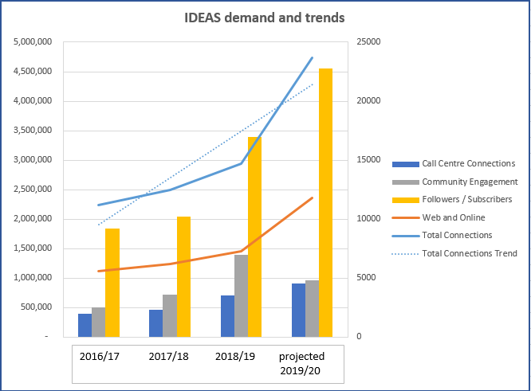
Chart 1: Three year (2016-2019) actual demand, and trend projection (2020) based on current operations.

See our 2018-2019 Annual Report – attachment.

Value for money
In 2018/2019 considering our total revenue against our total connections made, IDEAS delivered information to our customers at a value of $2.82 per connection – representing great value for money and demonstrating our model is efficient.

People have asked for information
There is no meaningful choice without access to independent, reliable information. The thing people first identified in the 2009 Shut Out Report, and in every report since, was information, yet it has not been delivered in a coherent, personalised, consistent and unconflicted way. [Disability Strategy Consultation Report prepared by the National People with Disabilities and Carers Council.2009.ISBN:978-1-92 1380-54-9]
39% of submissions to the Shut Out Report referenced access to quality one-stop-shop information was critical to removing barriers for people with disability in the areas of early intervention supports, services, education, health, housing, equipment and employment. This report highlighted that without information services to support decision making, Australia was at risk of not fulfilling her obligations as a signatory to the UNCRPD, the first of whose eight guiding principles is “Respect for inherent dignity, individual autonomy including the freedom to make one’s own choices, and independence of persons.” [UNCRPD Guiding Principles un.org]

Models
The idea of generalist information provision is critical to meet the aspiration of choice, control and personalisation in the evolution that Australia seeks as a nation for her citizens with disability. Just as a general practitioner is the hub in stewardship of health and wellbeing for patients, so too is generalist disability-related information a hub for referrals to disability peaks, support networks, and inclusive mainstream services, supports. It is also the gateway to specialist care as well as assisting navigation with state providers of health, education, housing, employment, leisure, travel and advocacy services. Steve Dowson referred to the Emprise Model in ‘Who Does What’ to identify which parts of the system should be separated to ensure independence for the individual, and identified information as a separate function to planning, advocacy support and service provision. [The Emprise Model, Who does What - Online edition, Steve Dowson, 1999]

Independence
IDEAS has a strong view that such a facility (NDIG) must be housed separate from the Agency, separate from government and separate from service providers to ensure independence- to be there to serve the individual only.
Advocacy uses information, but information can stand alone – it is a capacity builder and an enabler.

Key Considerations
Investment in this critical area for people with disability is imperative and needs to be independent of both the government and the Agency. The existence of a generalist independent information provider is critical in creating true inclusion in any community for people with disability, their families, carers and supporters. IDEAS’ model removes stress and alleviates the burden for people requiring information e.g.
- when a child is struggling at school
- when an appropriate health specialist can’t be found
- when you need to find some respite.

80% of barriers for people with disability are shared. So, just like a great general practitioner who is a trusted steward of one’s health, disease prevention and wellbeing, so is IDEAS a trusted information clearing house, curator and disseminator.

Characteristics Required for a Quality Independent Disability Information Gateway
IDEAS' extensive experience tells us a National Disability Information Gateway is sorely needed, with these critical elements:
- That it is run for and by people with disability or lived experience of disability
- That each person is listened to with respect for their individual circumstances, no matter where they live
- That a real person will answer the phone and deal with the enquiry, unscripted and untimed
- That many channels need to be used for information services, including telephone and live chat with real people, face-to-face, video, SMS, e-mail, social, digital and web interface as well as newsletters and e-news
- That the information is accurate and independent – that is, the organisation is not trying to sell the person anything
- That the information can be provided in accessible formats chosen by the customer

A National Disability Information Gateway (NDIG) Delivered Properly Will
- Provide unequivocal evidence that all Australians living with disability can be served by a one-stop, multifaceted portal to get the information they need to make choices for themselves
- Complement the NDIS
- Increase community confidence in a more inclusive Australia
- Vastly increase both the productivity and reach of LACS and Support Coordinators
- Minimise medium and long-term risks for ‘unfunded’ nonparticipants of the NDIS who cannot get what they need to lead a fulfilling, ordinary life wherever they live.

Options

Do Something Now!
- Stop the predictable rise of the dissatisfied voices who are getting nothing from our new great social reform.
- Create a National Disability Information Gateway – the current chaos and confusion will start to fade away. The ILC Current Investment Strategy will not deliver a national information program until 2022! and only targets the 1 in 5 people with disability that will become a NDIS participant. IDEAS delivers for all people with disability.
- A scalable model exists. Don’t re-invent the wheel and don’t throw the baby out with the bath water. IDEAS model is tried, tested, and true.

Create a Way for More People with Disability to Get Access to
- a trusted provider that uses a listening model for customisation and respect
- 35 years of experience and innovation in knowing what works in information provision for people with disability
- 50,000 up-to-date data sets on disability services, supports that will grow in scaling up
- where possible, building mainstream inclusion options
- face-to-face contact with an Information Officer at more than 250 events each year
- Information Officers that connected people with more than 700,000 pieces of information last year and answered calls from more than 3500 individuals.
People with disability will have access to a trusted source of information that uses a listening model to enable people with disability to exercise their right to choice and control.

Conclusion/Recommendation
We recommend the immediate investment of resources to get the NDIG up and running now, scaling up over three years, in line with the government’s election commitment. By giving this role to IDEAS and keeping IDEAS funded now and into the future, means there will always be access to high-quality, wide-ranging information when people need it most.
This would represent a ground-breaking act of inclusion as any person with disability or their families, carers and supporters could access the information and navigation support they need by whatever means suits them best, whether NDIS participants or not. People with disabilities will be empowered, in control and granted true choice.
The beginnings of a National Disability Information Gateway service can be rolled out now for all people with disability wherever they live. And that means people can get on with their best possible life without having to wait.

